Multi-Genre Thematic Unit Plan
Name
Institution
Date

NAME:

CONTENT AREA/SUBJECT: Mathematics GRADE LEVEL/COURSE: 6th Grade

Topic: The Number System (NS)

What is the topic/big idea for this content area unit?
- The number system and its application in the real-life situation.
- The order of operations
- Fractions and decimals
- Integers
What is the essential question for the unit (real-world connection)?
- How are numbers essential in real-life situation?
- What are the major elements of the number systems?
- How does number impact the field of learning and especially math?

CONTENT AREA Standards selected for this unit:
- Round, compare, and order whole numbers up to one trillion
- Apply strategies in order to solve real-life problems
- Apply the order of operations in order to solve problems
LITERACY [ELA] Standards selected for this unit:
Standards listed from the Mississippi College- and Career Readiness Standards for Mathematics (https://sos.ms.gov/ACProposed/00021704b.pdf):
MS-CCRS-6.NS.1
Interpret and compute quotients of fractions, and solve word problems involving division of fractions by fractions.
MS-CCRS-6.NS.3
Fluently add, subtract, multiply, and divide multi-digit decimals using the standard algorithm for each operation.
MS-CCRS-6.NS.4
Find the greatest common factor of two whole numbers less than or equal to 100 and the least common multiple of two whole numbers less than or equal to 12. Use the distributive property to express a sum of two whole numbers 1–100 with a common factor as a multiple of a sum of two whole numbers with no common factor.
MS-CCRS-6.NS.6
Understand a rational number as a point on the number line. Extend number line diagrams and coordinate axes familiar from previous grades to represent points on the line and in the plane with negative number coordinates.
MS-CCRS-6.NS.7
Understand ordering and absolute value of rational numbers.
MS-CCRS-6.NS.8
Solve real-world and mathematical problems by graphing points in all four quadrants of the coordinate plane. Include use of coordinates and absolute value to find distances between points with the same first coordinate or the same second coordinate.

Multi-Genre Thematic Unit Plan
Instructional Time: ___6____ (# of days)
Learner Outcomes
Content Area Outcomes:
By the end of the unit, the learner will be able to:
- Develop number sense (Time for Learning, 2018)
- Use roman numerals to solve problems
- Apply strategies in order to solve real-life problems
- Round, compare, and order whole numbers up to one trillion
- Apply the order of operations in order to solve problems
- Use variables in order to simplify expressions
- Identify least common denominator as well greatest common factor
- Compare and order fractions including using a number line
- Use integers to describe real-life situations and show them on a number line
Literacy Outcomes:
By the end of the unit, learner will be able to:
- Participate in peer groups and collaborate to solve mathematical problems
- Use text features such as graphs, charts, and diagrams to help them better understand the text
- Combine information from two or more texts and speak technically about the topic
- Develop a timeline via effective use of information and media from their own research
- Develop presentations as well as include visual displays to create an intent

Materials, Equipment, and Supplemental Resources:
The Number System
Day 1:
Sixth grade mathematics standards and curriculum
Number line recognition pre-test
The factor game board
Readable charts and graphs
Computers with Internet connection
Day 2:
Sixth grade fractions and decimals thinking worksheets
Computers with Internet connection
Day 3:
Fractions and decimals grade 6 worksheets
Computers with Internet connection
Day 4:
Operation of numbers recognition pre-test
Charts on operation of numbers
Computers with Internet connection
Day 5:
Integers and graphing recognition pretest
Charts on integers and graphing
Theoretical integers and graphing notes
Computers with Internet connection
Day 6:
Using integers in real-life situations recognition pretest
Tables of values
Coordinates and Graphs

LESSON PHASES | DAY 1 CONTENT FOCUS: | DAY 2 CONTENT FOCUS:
1.Introductory – Before Learning/Reading Phase | The student will be categorized into groups of four to read out a graphic organizer on number systems (Appendix 1).  The teacher will post the first chart on the board and allow students to contribute by adding what they know about number systems. | The teacher will show students readable charts and graphs on number systems.
2. Developmental – During Learning/Reading Phase  Teacher Facilitation | The teacher will begin by reading the notes on number line theory and systems.  The following keywords will be added in the number line exploration wall: Rounding off, compare, and order.  The teacher will ask students to name some numerical numbers they can see in the number system  The teacher will ask the student to round, compare, and order whole numbers up to one million  Students will have an opportunity to name words they have heard while going through the content | The teacher will ask students about something we find different about even, old, and prime numbers (See Appendix 1).  Let us look at operation of number by rounding off, comparing and arranging them in a good order.
3. Developmental – During or After Learning/Reading Phase  Student Engagement and Response | Using the factor game board, students will participate in the number theory and systems by categorizing numbers as old, even, and prime  Students will be required to go through readable charts and graphs on their own (See Appendix 1).  Computers with an Internet connection | The student will complete reading the charts and graphs
4. Concluding – After Learning/Reading Phase | Now that we have read about number theory and system, let us look at how they apply by solving real-life situations. | Now that we have a general introduction, it is the high time to read more about them

LESSON PHASES | DAY 3 CONTENT FOCUS | DAY 4 CONTENT FOCUS
1.Introductory – Before Learning/Reading Phase | To your understanding, why are the number systems essential in real-life problems?  Today we are going to learn about fractions and decimals. | What did we read about in our previous lesson?  Today we are going to learn about operation of numbers.  A web- quest will be applied to shed more knowledge about number system.
2. Developmental – During Learning/Reading Phase  Teacher Facilitation | The teacher will request students to read and analyze the presented graphs (Appendix 2).  While the graphs are being analyzed, the teacher will ask key questions:  What is denominator?  What are numerators?  What is the difference between numerator and denominator?  Do you find number system essential in normal life situations? | The teacher will show web-quest to the class and help them to go through the instructions the need to complete about number operations.  The teacher will guide the students by giving them guidelines to make sure that they are much aware of what they need to accomplish for effective number operations.  The teacher will give examples of number operations via adding, subtracting, multiplying, and dividing fractions.
3. Developmental – During or After Learning/Reading Phase  Student Engagement and Response | The student will read the provide graphs and charts  The student will complete the presented factor game  The student will compare and order fractions including using a number line. | The students will complete the exercise questions in groups.
4. Concluding – After Learning/Reading Phase | The teacher will have students to:  Differentiate between denominator and numerator  Compare and order fractions using a number line | The teacher will provide a well-developed questions sheets to provide the answers they find correct

LESSON PHASES | DAY 5 CONTENT FOCUS | DAY 6 CONTENT FOCUS
1.Introductory – Before Learning/Reading Phase | In the previous lesson, we learned about operation of numbers. Today we will be looking at integers and graphing.  Computers with internet connection will be of great importance in this lesson.  We will watch video about the application of integers in real-life situation in regard to number line. | In our previous class we learned about using integers in real-life situations.  Today, we are going to learn about adding, subtracting, multiplying, and dividing using integers.
2. Developmental – During Learning/Reading Phase  Teacher Facilitation | The teacher will show students the video about integers and graphing  The video is quite informative and hence it is necessary to emphasis on what is important.  The teacher will help the students by describing a real life situation and show them on a number line.  The teacher will ask student to provide and real life example that they have ever applies number line before | The teacher will ask students simple questions about operation of numbers and show how this knowledge applied in operation of integers.  The teacher will do samples in each of the integer operations.
3. Developmental – During or After Learning/Reading Phase  Student Engagement and Response | The student will respond to questions about the video concerning real life application of number line.  The student will share their response to these reflective questions to the entire class.  The student will respond to at-least two or more student’s initial posts and show desire for additional knowledge. | The teacher will test the learners understanding.  The teacher will pull sticks to call students to tell the results of each operation. Students who will not be able to give the exact response will be guided by the teacher on how to get it correct.
4. Concluding – After Learning/Reading Phase | The teacher will ask student to share what they have learned as a result of completing the exercise. | The student will complete quizzes on integer operations

Tutor’s Reflection
Mathematics is a quite interesting but complicated discipline and hence learners should be properly guided on how to perfect on this knowledge. The content framework for this study greatly impacts my knowledge as a teacher. It provides a thorough understanding of the students’ abilities in the context of mathematics and its application in the real-life situation.
In regard to the element of reading, I applied varied techniques such as reading graphs and charts. I also applied easy tests for students in the sixth grade of learning. This element has enhanced my understanding that student need to be served with a good learning environment for them to develop interest to the subject. I learned that there are varied strategies which can be put in place in order to solve real-life problems.
I have also learned that effective teaching and learning experience should suitably help students to apply the general knowledge through writing and making comparisons. Such a practice will help the teacher to identify evident knowledge gaps and take a move towards addressing the evident gap. More importantly, a teacher must be reflective of the student’s speaking and listening abilities (Pontryagin, 2018). In tried to apply videos in my teaching practices and the students were highly fascinated and they maintained focus to the entire system. Student were able to nature their language through communication and participation.
Overall, I gained the understanding that number sense is very essential for learners and it encourages to think flexibly and it promotes their confidence with numbers. I also observed that students come to comprehend that numbers are quite meaningful and the affiliated results are quite sensible, expected, and applicable in real life situation.
As a curriculum director, I have gained the understanding that all teaching and learning approaches should be learner centered. They should serve the learner with adequate understanding to the material significance of learning mathematics in the modern society. I would use knowledge gained from this study to advocate for the necessary changes in curriculum development to ensure that not only sixth grade students but also all levels of learning are served with knowledge that best fits their abilities in a progressive manner.

References
Pontryagin, L. S. (2018). Mathematical theory of optimal processes. Routledge.
Roberts, K., & Brugar, K. (2017). The three R’s: reading,(W) Riting, and researching through multi-genre project. Social Studies Research and Practice, 12(1), 42-55.
Time for Learning, (2018). Sixth Grade Math Activities & Curriculum. Retrieved from https://www.time4learning.com/sixth-grade-math.shtml

Appendix 1:
Introduction to the Number System
Definition: Number system is the way to represent a number in different forms.
Types of Number system:
- Binary Number System: It is the number system with base value 2 means it has only two digits to represent the data. The digits are (0, 1). E.g. 00,01,10,11,100….
- Decimal Number System: It is the number system with base value 10 means it has 10-digits to represent the data. The digits are(0-9). Eg. 0,1,2,3,4,5,6 ………
- Octal Number System: It is the number system with base value 8 means it has 8 digits to represent the data. The digits are ( 0-7).
- Hexadecimal Number System : It is the number system with base value 16 means it has 16 digits to represent the data. The digits are (0-15). Eg. 0,1,2,3…….,9,A,B,C,D,E,F

Bits & Bytes:

1 bit(binary digit) = 1 digit. For example: 1
1 byte = 8-bits
1 kilo byte= 2¹⁰ = 1024 bytes
1 mega byte = 2¹⁰ * 2¹⁰ = 2²⁰ = 1024 kilo bytes
1 giga byte= 2³⁰= 1024 mega bytes
1 tera byte= 2⁴⁰= 1024 giga bytes

Binary Number System:
In binary number system is made up of 2 digits- 0 and 1. We use these two digits to represent data.
0 | Start at 0
1 | Then 1
??? | Then no other symbol

So we count in the same way as using decimal number system. For example:
Decimal number system start at 0 and then 1,2,3,4,5,6,7,8,9… now what after nine repeat the no in combination such as start at 0 again the add 1 to the left of 0 resultant 10 , 11 ,12… so on. 100, 1000 etc.

The same method we follow in Binary number system:
So confused! how we get this?

Decimal Number | Binary Value | Decimal Number | Binary Value
0 | 0 | 6 | 110
1 | 1 | 7 | 111
2 | 10 | 8 | 1000
3 | 11 | 9 | 1001
4 | 100 | 10 | 1010
5 | 101 | 11 | 1011

Let’s do a little Mathematics:
2⁵ 2⁴ 2³ 2² 2¹ 2⁰ =
Confuse again? Have a look on the bold letter 2, 1 is representing that 2
32 16 8 4 2 1
0= 0 0 0 0 0 0
1= 0 0 0 0 0 1
2= 0 0 0 0 1 0
3= 0 0 0 0 1 1
4= 0 0 0 1 0 0
5= 0 0 0 1 0 1
6= 0 0 0 1 1 0
STOP? Are you able to create the binary counting
7= 0 0 0 1 1 1
8= 0 0 1 0 0 0
9= 0 0 1 0 0 1
10= 0 0 1 0 1 0

If no, Just look at the power values : 2⁰, 2¹, 2², 2³, 2⁴…….2^{n}
2⁰= 1
2¹= 2
2³= 8
2⁴=16 so on…..
Hexadecimal Number system:
This number system has a base value 16. We can use (0-15) decimal numbers to represent hexadecimal numbers. It uses 16 distinct numbers to represent the values.

Decimal numbers | Binary Number | Hexadecimal Number
0 | 00 | 0
1 | 01 | 1
2 | 10 | 2
3 | 11 | 3
4 | 100 | 4
5 | 101 | 5
6 | 110 | 6
7 | 111 | 7
8 | 1000 | 8
9 | 1001 | 9
10 | 1010 | A
11 | 1011 | B
12 | 1100 | C
13 | 1101 | D
14 | 1110 | E
15 | 1111 | F

ASCII (American Standard Code Interchange Information) Code: ASCII is a character set that is used to interchange information to binary and from binary to decimal. ASCII is a 8-bit character containing 256 characters.

0-31 | Control code
32-127 | Standard, alphabet A-Z and a-z
128-255 | Special Symbols, non standard characters

Unicode: Unicode is a character set that is used to interchange information to binary language and from binary to decimal language. The latest version of Unicode is Unicode 6.0. It is a computing industry standard encoding scheme to represent a text.

Appendix 2
Operation of fractions
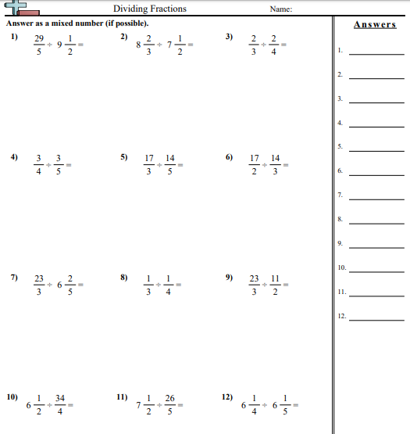

Appendix 3:
Finding Greatest Common Devisor
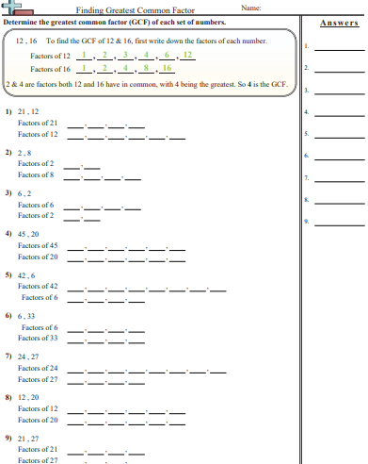

Appendix 4
6th Grade 5-1: Integers and Graphing
https://www.youtube.com/watch?v=Xq6ZdoZ-_zU
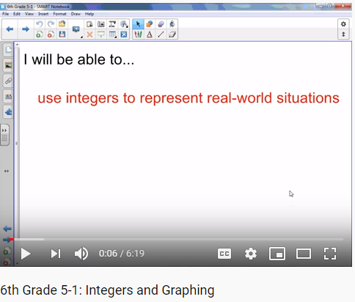

Appendix 4:
Operation of Numbers
